Oswego County P-TECH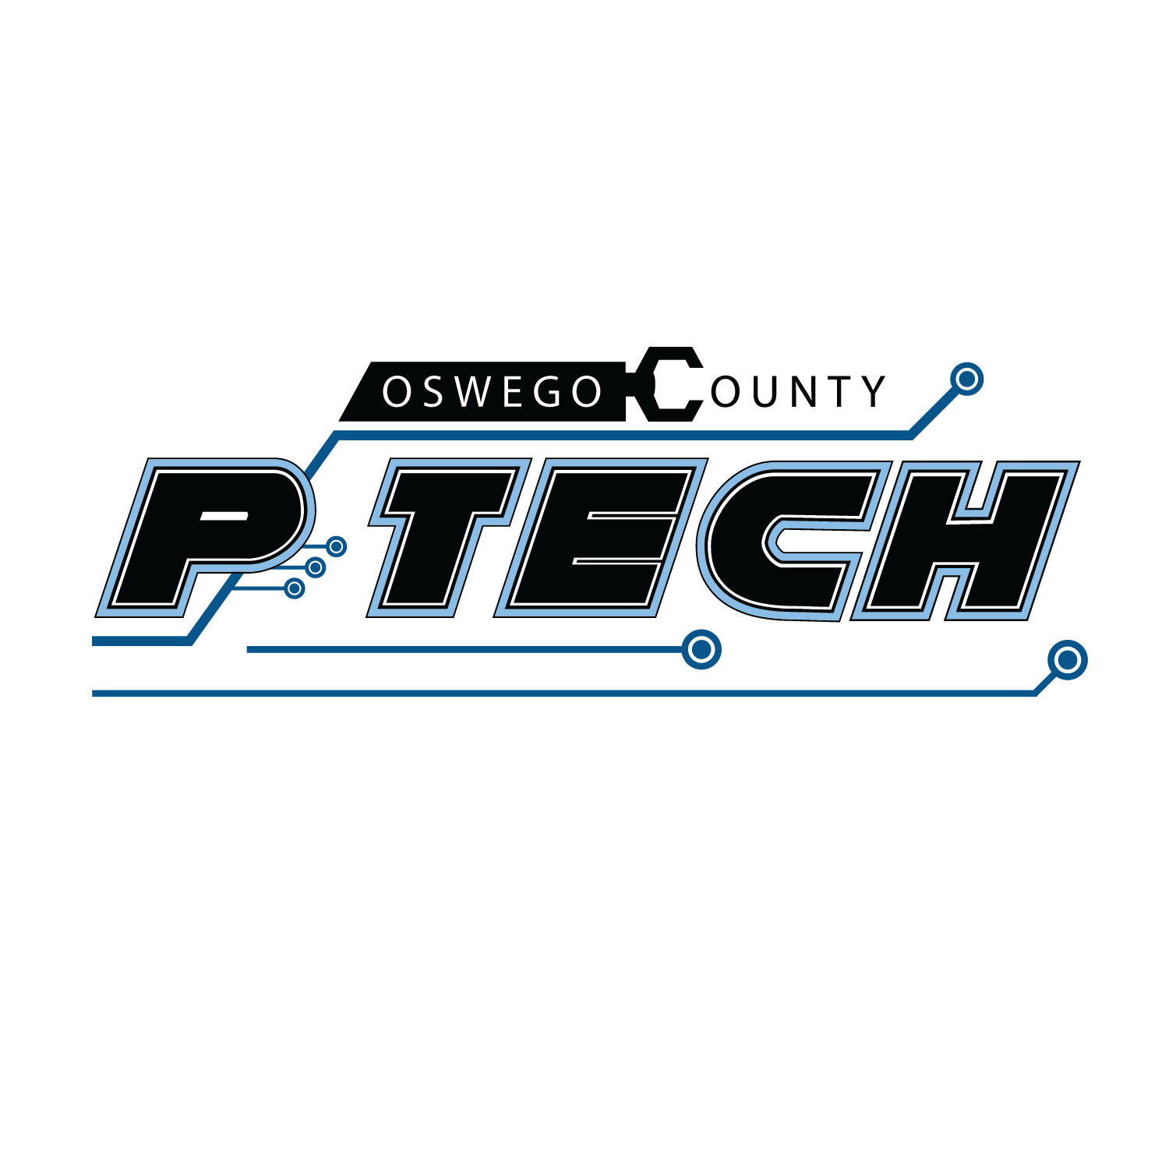

179 Co.Rt. 64

Mexico, NY 13114

P:315.963.4248

[ptech@citiboces.org](mailto:ptech@citiboces.org)

July 29, 2025

Welcome back, PTECH families! The purpose of this letter is to let you know about important upcoming dates and to welcome you to our Onondaga Community College informational sessions. This is an exciting time for our 11th graders as they transition to college life.

**Upcoming Important Dates:**

| August 11, 12 or 13, 2025 | *OPTIONAL* OCC tour- 12-2pm or 6pm  We sent information previously about signing up for an optional tour. Please let us know if you need this information again.  If you filled out the form already, we will contact you with your appointment time. |
| --- | --- |
| August 20, 2025 | OCC Virtual Orientation- 11am AND 6pm (you only need to attend 1 session)  The link to join our meeting is:  <https://zoom.us/j/96865677032?pwd=bHZobdH9ebFFdBFlr8bssPtaAK0v8h.1>  Meeting ID: 968 6567 7032 Passcode: 084073 |
| August 25, 2025 | OCC - Classes Begin (Fall 2025) |
| October 22, 2025 | PTECH Open House at 6pm (CiTi BOCES Mexico) |

**Import Information:**

* Contact Information
* Instructional Calendar (CiTi and OCC)
* Cell Phone Policy
* Student Attendance and Expectations
* Course Offerings/Schedules
* Transportation/ Inclement weather protocol
* Text Books

In the meantime, please feel free to reach out with any questions at [ptech@citiboces.org](mailto:ptech@citiboces.org) or our main office at 315-963-4248.

Thank you, 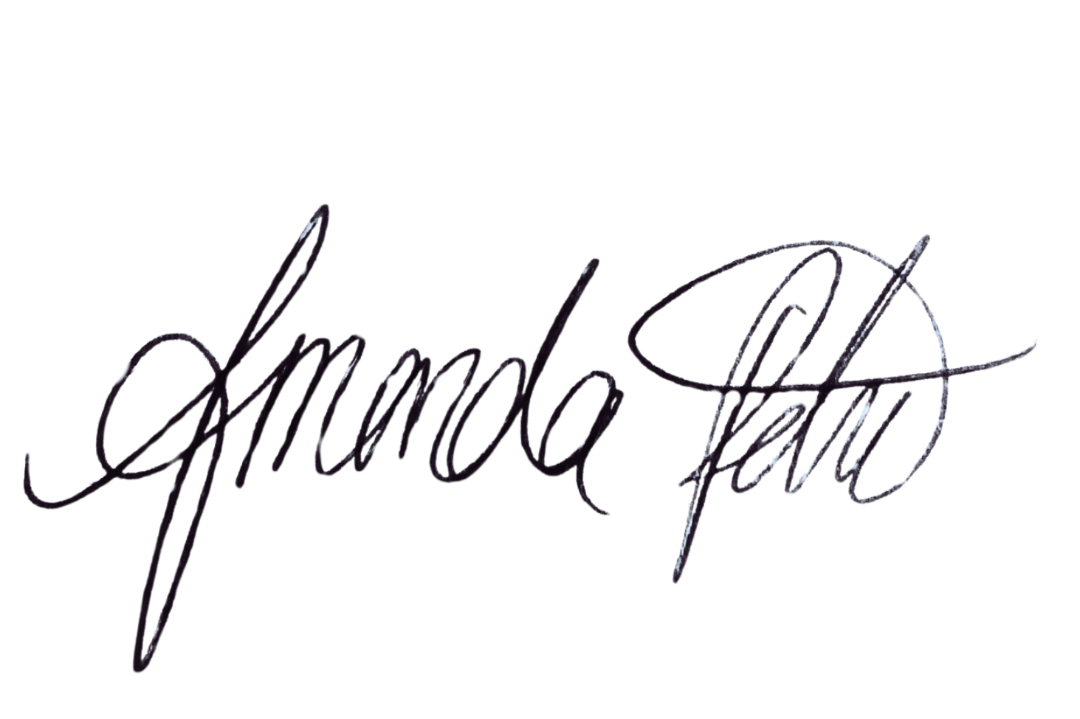

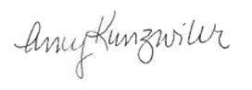

Amanda Petrie Amy Kunzwiler

PTECH Principal PTECH Assistant Principal